Project Design Phase
Solution Architecture

Date | 02/10/2026
Team ID | SWTID-2026-3118
Project Name | IMPORT DATA USING TRANSFORM MAPS (SPREADSHEET)
Maximum Marks | 4 Marks

Solution Architecture:
Solution architecture is a complex process – with many sub-processes – that bridges the gap between business problems and technology solutions. Its goals are to:
- Find the best tech solution to solve existing business problems.
- Describe the structure, characteristics, behavior, and other aspects of the software to project stakeholders.
- Define features, development phases, and solution requirements.
- Provide specifications according to which the solution is defined, managed, and delivered.

Project Solution Architecture Diagram:

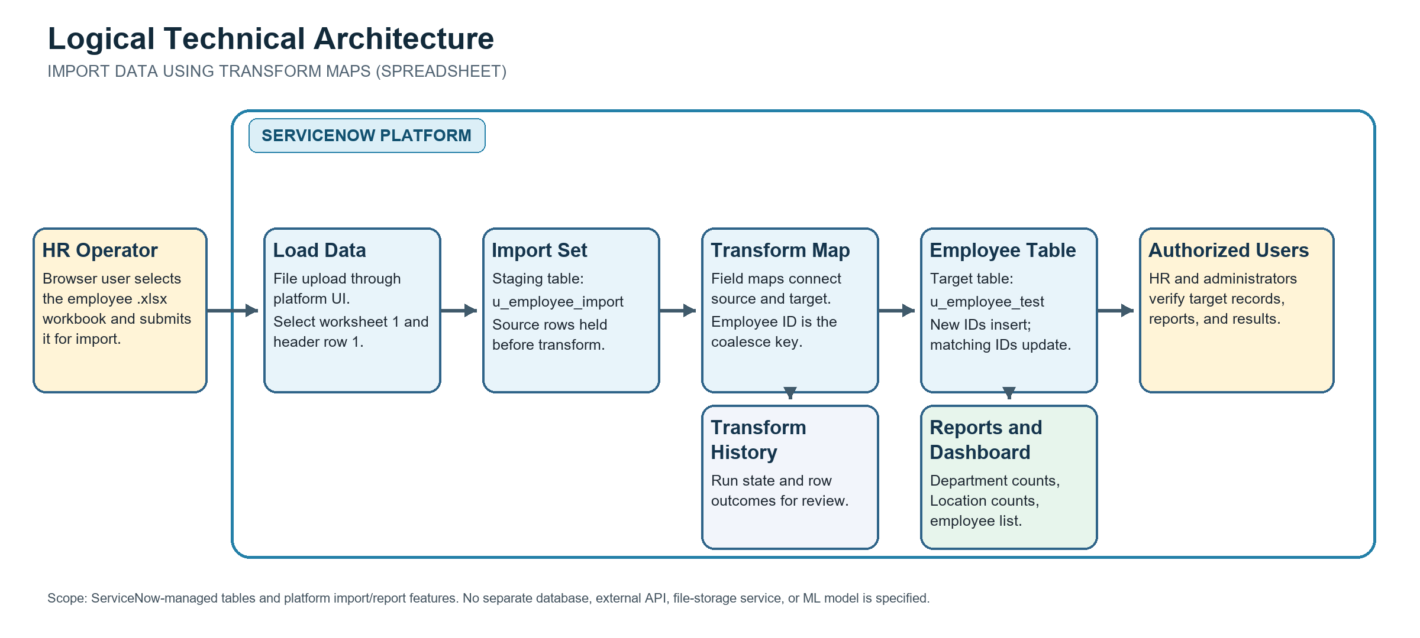
Scope note: the design assumes a user-initiated .xlsx import into ServiceNow. Instance release, expected row volume, access roles, and processing targets must be confirmed for deployment.
Figure 1: ServiceNow architecture and data flow for the employee spreadsheet import solution.
Platform behavior references:
Import Sets key concepts: https://www.servicenow.com/docs/r/xanadu/integrate-applications/system-import-sets/c_ImportSetsKeyConcepts.html
Create a field map and coalesce: https://www.servicenow.com/docs/r/integrate-applications/system-import-sets/t_CreatingAFieldMap.html

